**How To Identify Entry and Exit Points in Stock Market**

[[](https://www.linkedin.com/company/stobotics/)](https://www.linkedin.com/company/stobotics/)

**[Stobotics](https://www.linkedin.com/company/stobotics/)**

934 followers

July 27, 2023

Success in the stock market is dependent on the price which you enter and what price you exit the market.

Profits in trading/stock is a delightful feeling for many of us. However, we also can’t deny the fact that trading comes with its own set of challenges. And finding an entry and exit point is one of them. This is also important as no trading strategy can be built without entry and exit points.

How do you identify entry and exit points in the stock market?

Many traders use various software which comes with inbuilt strategies to find entry and exit points.

However, there are Traders who also use various combinations, tools, and technical indicators to make their decisions.

Following are some of the most popular and used entry and exit point Indicators.

**1. Moving Average**

The moving Average is a popular yet slow-moving technical indicator used by many traders to identify entry and exit points.

It basically calculates the average price of a stock for a 10 days period, filters out the data and short-term fluctuations, and provides a clear trend direction.

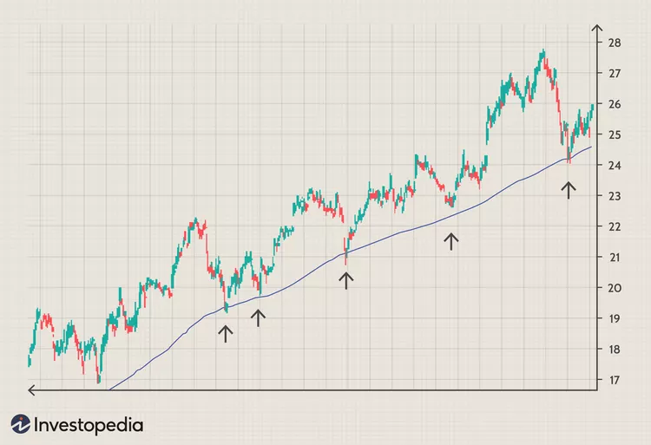

When the stock price rises above the moving average it indicates an entry point and when it falls below the average moving line, it indicates an exit point for Traders.

**2. MACD Moving average convergence divergence**

MACD is a versatile indicator used to understand the moment and trend direction of the stock price.

It consists of two lines —the MACD line (the difference between the 12-day and 26-day exponential moving averages) and the signal line (a 9-day exponential moving average of the MACD line)

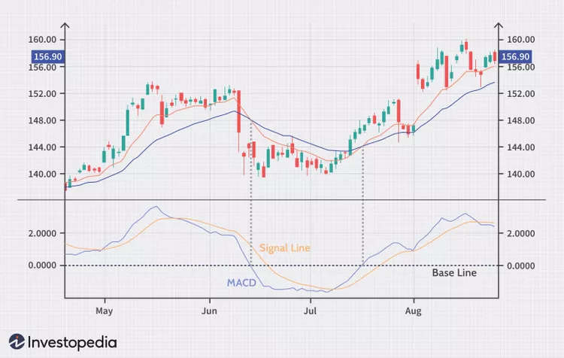

When the MACD line rises above the signal line it creates a bullish crossover. This indicates traders as buying opportunities also known as entry points.

Whereas, when the MACD line falls below the signal line, it creates a bearish crossover. This indicates traders as selling opportunities also known as exit points.

**3. RSI (Relative Strength Index)**

RSI is another technical indicator that measures the speed and price change movements that indicates overbought and oversold conditions in the market. RSI is measured on a scale of 0 to 100.

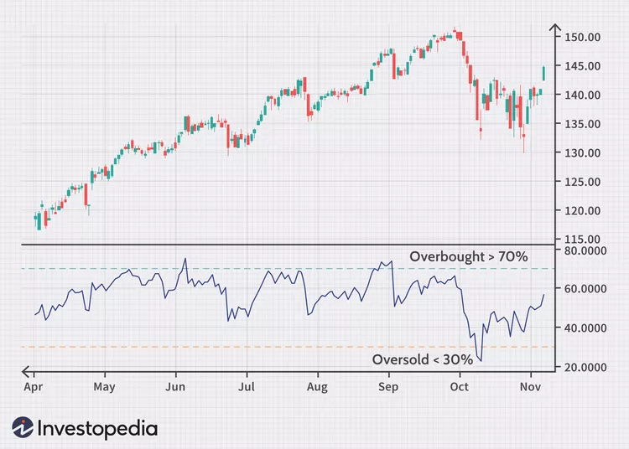

When RSI goes less than 30, it is considered an oversold stock. This means the price of the stock has declined rapidly and there could be a possibility of the reversal or going upward.

On the flip side, when the RSI goes above 70, the stock is considered overbought. This indicates that the asset price has risen rapidly and suggests a possible reversal or downward movement.

To identify entry points, traders focus on less than 30 indicators which is a potential buying signal for them .

And for exit points, they focus on the above 70 indicators which indicates a selling signal for them.

**4. Stochastic oscillator**

A stochastic oscillator compares a stock’s closing price to its price range over 14 days period. And provides insights into potential overbought and oversold conditions.

The stochastic oscillator is measured on a scale of 0 to 100.

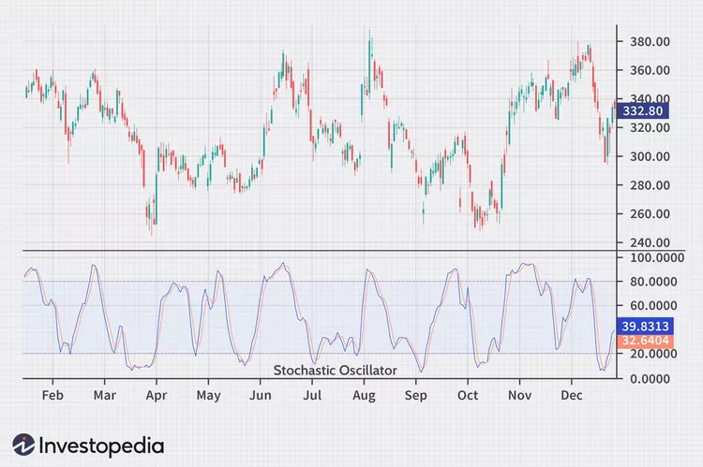

When it goes above 80, it is considered an overbought situation. Whereas if it goes below 20, it is considered an oversold situation.

To identify entry points, traders focus on oversold where the stochastic oscillator crosses above 20. And for the exit point when the oscillator rises above 80.

**5. Bollinger bands**

The ups and downs of the price in traders are determined by the Bollinger Bands.

Bollinger bands consist of 3 lines — One is for the upper level, the second is for the lower level and the third is for the moving average.

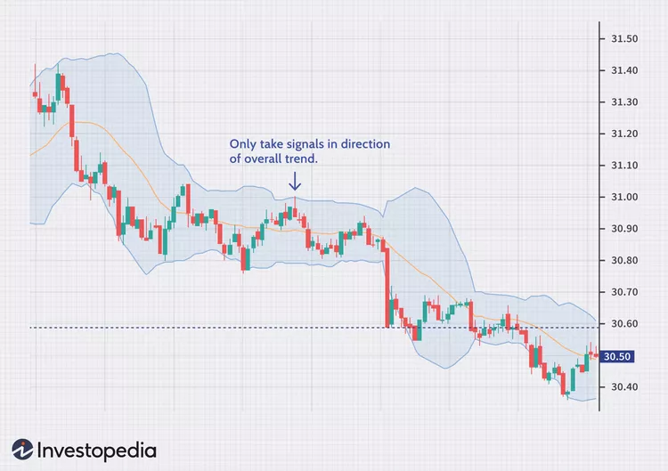

When the price moves closer to the upper level, it is considered as the market may be overbought. And on the other hand, if the price is closer to the lower line it indicates the market maybe oversold.

Here, you can find entry points, when the price moves the upper band. It generates a bullish entry signal and is a good possible opportunity to buy them.

Conversely, you can identify the exit point if the price breaks below the lower band. It generates a bearish entry signal, which is a possible time to take profits or consider long positions.

It is not always easy to find entry and exit points. Practice and perseverance go a long way.

You can come up with or create your own strategy or use different indicators to find entry and exit points.

Additionally, also understand your risk appetite. You can also use stop-loss orders to protect your capital and avoid excessive losses.

Also, do your homework — research and study the stocks you would want to invest in . This will ensure you that you are ahead of the curve and this can help you make good returns on your investment.

Learn – [Top 5 option trading strategies](https://www.stobotics.in/business/top-5-option-trading-strategies/)